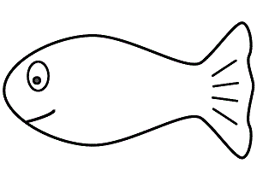 

 

 

 

**www.kidsactivities.gr**